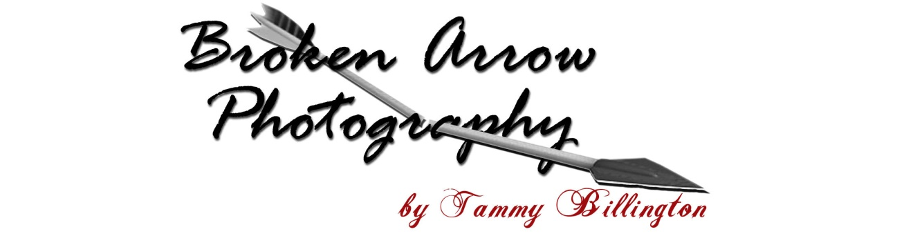

# *Portrait Rates…*

**$50.00 Creation Fee**- This is a separate charge to cover time and materials of your photo shoot. Creation fee is due at time of shoot and does not include any finished portraits or previews.

**$40.00 On Location Fee**- Photo shoot at your favorite spot.  This additional fee is to cover mileage and travel time.

**$40.00 Deposit**- when you check out your preview album.

**Order Date**- 50% of balance is due to process the order. Remaining balance due when you pick up your order.

### Create Your Own Package

  3 x 5           $  5.00                           **Wallets.....**

  4 x 6           $  8.00                                    8 - 1 Pose            $10.00

  5 x 7           $12.00                                  16 - 1-2 Poses       $20.00

  8 x 10         $20.00                                  32 - 1-2 Poses       $30.00

11 x 14         $32.00                                  50 - 1-2 Poses       $40.00

16 x 20         $42.00                                  75 - 1-3 Poses       $50.00

20 x 30         $62.00                                100 - 1-5 Poses       $60.00

***Preview Album...***will have 20 to 160 photos depending on amount of poses, outfits and locations.

***Preview Album*** can be purchased after a minimum order of $100.00.  Cost of album will be $50.00.  That is my cost to make it.  Receive it FREE with a $250.00 portrait order.

***Black folio*** with 8 previews available for $65.00

**Custom Made Photo Album**…8 x 10 for $75.00

************************************************************************

**Budget Package....$175.00**

Studio and outside shots

  Get ***at least*** 20 4 x 6 prints in color and black/white

  Copy of CD and Release form...allows you to make copies from disk

Tammy Billington

30780 Pee Dee Road

#### Keytesville, MO 65261

Phone (660) 777-3601 Cell (660) 651-5306

Email: [brokenarrowphotography@hotmail.com](mailto:brokenarrowphotography@hotmail.com)

Website: <http://brokenarrowphoto.tripod.com>